Maven Project in Eclipse

1. Open your *eclipse and* *Go to File > New >* Others.

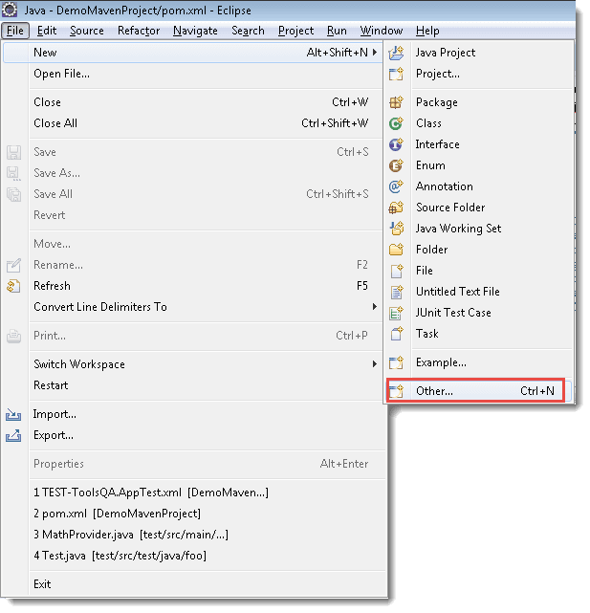

2) Select ***Maven Project***and *click* on *Next.*

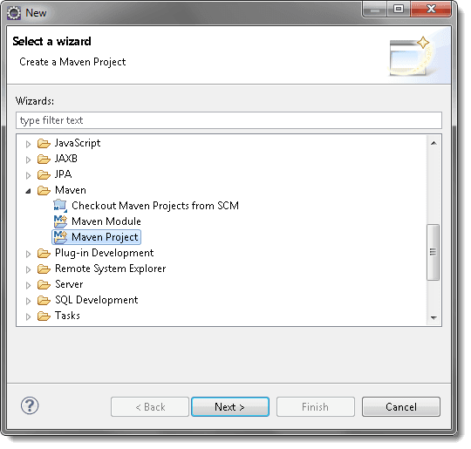

3) *Un-check* the ‘***Use default Workspace location***‘ and with the help of the ***Browse***button choose your *workspace* where you would like to set up your *Maven project*.

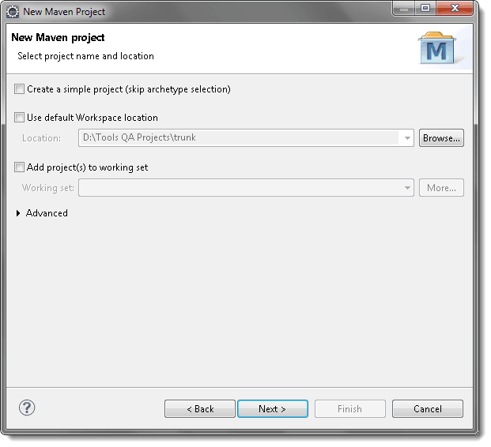

4) Select the *archetype*, for now just select the ‘***maven-archetype-quickstart***‘ and *click* on ***Next***.

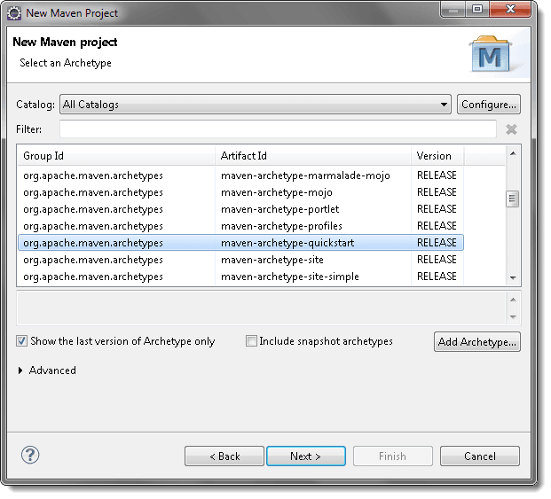

5) Specify the ***Group Id*** & ***Artifact Id*** and *click* on ***Finish***.

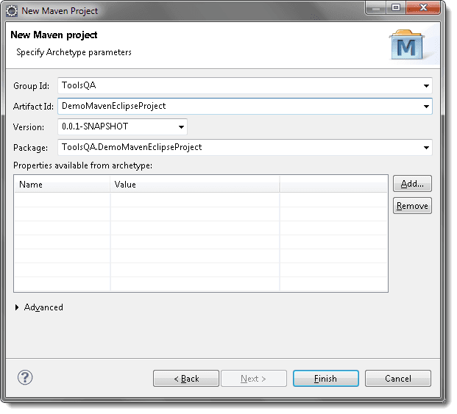

6) The newly created maven project. Now open the *pom.xml* file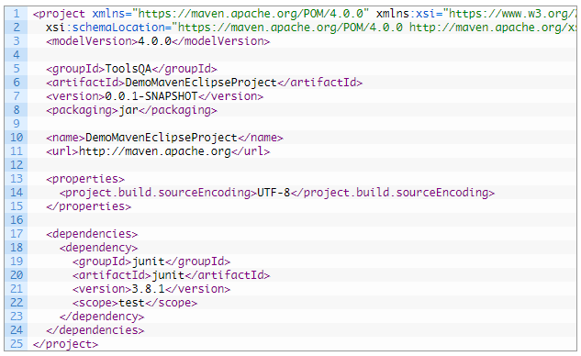

1. Select **Run As** option. Then select **Java Application**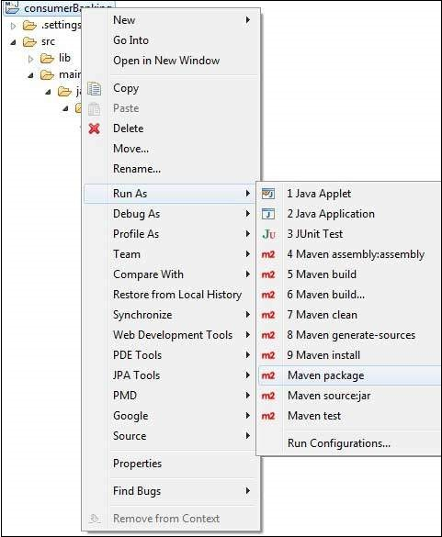

Project Run configuration

